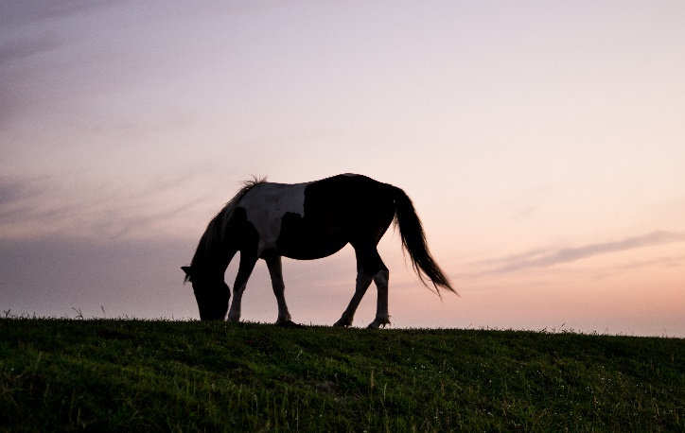

Little Bear Stables

Thank you for your interest in adopting an equine from Little Bear Stables. We are a small licensed farm dedicated to rescuing, rehabilitating and rehoming abused, neglected and slaughter-bound equines. We provide equine rescue regardless of age or disability. All adoption fees are put back into our rescue program in order to support the current rescue horses at our farm. Once the adoption fee has been set, we will not take less than the offered price. Please keep in mind that we typically invest far more into each horse than what we can adopt a horse for. Fees are based upon the horse’s age, abilities and amount of training. The adoption fee is due and must be paid, when adopter is approved and has agreed to adopt said horse(s). We do not accept payment plans. Please keep in mind that when you are adopting a rescue horse, you are making a commitment for the remainder of its life. Horses that are treated properly can live to be 35 years of age or older. Please be sure to read our adoption guidelines found on our website. Our goal is to find each rescued horse a compatible and loving forever home. All adoption applications are reviewed on a first come, first served bases. We have the right to decline your application if the requirements are not met. Please fill out the attached paperwork and return it as soon as possible. Please, also contact your veterinarian and give authorization to speak with us as a reference. Once we review your application, we will contact you to inform you whether or not your application has been approved, pending the barn check. We appreciate your interest in adopting an equine from us.

Thank you,
Little Bear Stables.

Adoption Application
Name:
Address:

Phone Number: E-Mail Address:
Place of Employment:

Employment Address: Phone Number:

Veterinarian’s Name: Veterinarian’s Number:

Farrier Name & Number:

Have you ever been convicted of Animal Cruelty? ______ YES ______ NO
If yes, please explain:

Will the horse to be stabled on your property or boarded out?

If on your property, number of acres the horse will be pastured on:

Are you a current horse owner? ___ Yes ___No

If yes, # of years:

If no, have you owned a horse in the past?

# of horses currently owned?

# of horses on this property?

If boarded out, name of stable or boarding facility:

Address of boarding facility:
Phone number of boarding facility:
Owner of boarding facility:

Is there shelter provided for the horses?

Number & size of stalls in barn:

Amount of time turned out?

Please describe what purpose your adopted horse will serve in your lives:

Please describe what type of horse that you are seeking:

What is the horse’s name that you are applying to adopt? A current list of our available horses can be found on our website.

Additional Comments:

**Please note, we take the adoption of our rescue animals very seriously. By agreeing to this adoption contract you are agreeing to keep this horse in your possession, safe, well cared for, for the rest of it’s life. If you are unable to care for your horse for any reason, you are required to bring the horse back to us so we can make sure they are placed appropriately. All adoption fee’s are non-refundable**

Signature _________________________ Date __________________

